EMS Department Name: _________________________________

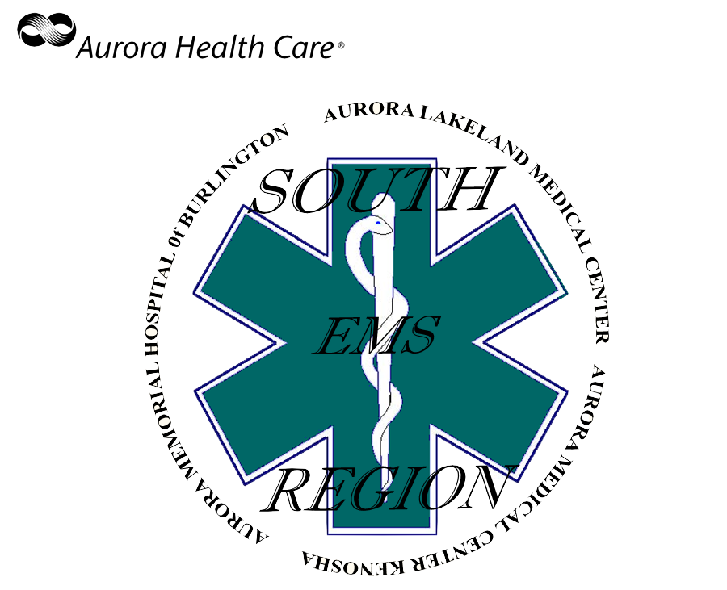
Initial Affiliation Licensure Upgrade/Downgrade Transfer or from another squad

EMS Provider Demographics:

Name: ________________________________________

Address: ________________________________________

City: ________________________________________

Zip: ________________________________________

Phone Number: ________________________________________

Email Address: ________________________________________

DOB: ________________________________________

License Number: ________________________________________

NREMT Number: ________________________________________

Primary Department: ________________________________________

Alternate Department: ________________________________________

Alternate Department: ________________________________________

Affiliation Completion Checklist:
Date of Affiliation: _________________
Affiliation Completed By: _________________________________
Passed Skills Testing: Yes No Deferred Written Test Score: ___________
Medical Patient Assessment Trauma Patient Assessment
Non-Visualized Airway Defibrillation Automated/Semi-Automated (AED)
Affiliated with department in E-Licensing: Yes No
Approved by Service Director: Yes No
Approved by Medical Director: Yes No
EMR Scope of Practice ** Items
Please mark all that the candidate has been trained in and approved to use
Non-Visualized Airway
King Combi-Tube i-Gel
CO Monitoring
Long Board Immobilization
Cervical Collar Spinal Immobilization
Seated Patient Spinal Immobilization (KED)
Hemostatic Agents
Glucagon Auto-Injector
Albuterol
Epinephrine for Anaphylaxis (Auto-Injector or Manually Drawn)
Naloxone Administration

Affiliation Checklist:

Licensure Items

- Maintain all state-required certifications for licensure which include American Heart Association Basic Life Support for Healthcare Providers (BLS) or equivalent (for all licensure levels) and American Heart Association Advanced Cardiac Life Support (ACLS) or equivalent for all EMT-Intermediates (ALS) and EMT-Paramedics.
AHA BLS Expires: _____ AHA ACLS Expires: _____ AHA PALS Expires: _____
- Maintain a State of Wisconsin EMS license for the level of care the candidate is providing as described in Wisconsin Administrative Code DHS 110 and the Medical Director’s protocols.
- Maintain an e-Licensing account with the State of Wisconsin as outlined in Wisconsin Administrative Code DHS 110.

Continuing Education

- Read all assigned online learning packet and complete the written exam with at least 80% correct to pass. This is done as needed and participants will receive a minimum of two hours medical director approved continuing education credit that can be used toward Wisconsin EMS license renewal.
- Attend one of the scheduled in-person trainings held throughout Walworth, Kenosha, and Racine counties each quarter. This is done once each quarter and participants will receive a minimum of two hours of medical director approved continuing education credit that can be used toward Wisconsin EMS license renewal.

- Should the EMR/EMT be unable to complete this requirement, with early notification to the EMS office we will identify options to complete this requirement.

- Outside training and higher education (e.g. Paramedic or nursing school) can be used to meet these training hours under certain circumstances. The EMR/EMT must contact the EMS office prior to the close of the quarter for medical director approval.

EMS Medical Professionals Website and Continuing professional Development Website
6) Create an account on the https://cpd.aurora.org/ website.
Added to the EMS Learning Group Date: __________________
Audits and Reviews
- In the event a Quality Assurance issue develops, any EMR/EMT involved MUST make themselves available to meet with the Medical Director and/or his designee.

Maintenance of Affiliation

- The EMR/EMT must keep on file with the EMS office a current phone number and email address where they may be contacted.

- It is the responsibility of each EMR/EMT to notify the EMS office of:

  - Any change in licensure status or eligibility for licensure; such as upgrade, downgrade, loss of driving privileges, or criminal conviction.

  - If the EMR/EMT is going on an extended leave of absence (i.e. greater than 30 days).

Submittal of Affiliation

Signature of Candidate: ______________________________________________ Date: _____________

Signature of EMS Coordinator: ________________________________________ Date: _____________

ALMC EMS Coordinator AMCB EMS Coordinator Other

Signature of Service Director: _________________________________________ Date: _____________

Skills testing may be differed if the candidate has successfully passed a National Registry Emergency Medical Technician exam at their licensure level within the past six months or currently affiliated with Aurora South Region EMS and is in good standing.
The candidate is expected to maintain familiarity and proficiency with the Aurora South EMS Protocols. This will be tested annually.
If the EMR/EMT is affiliated with two or more squads, this requirement only needs to be completed once, but at the EMR/EMT’s highest licensure level.
This training can also be used to satisfy NREMT recertification education requirements.
Must attend in-person three of the four quarters to meet this requirement.
This training can also be used to satisfy NREMT recertification education requirements.

