To order Ear Seeds, login to your account on https://wellevate.me/advocate-aurora-health.
If you do not have an account, create an account here.
Once you are logged in, use the ‘product search’ in the upper right hand corner of the web page to search ‘earseeds.’
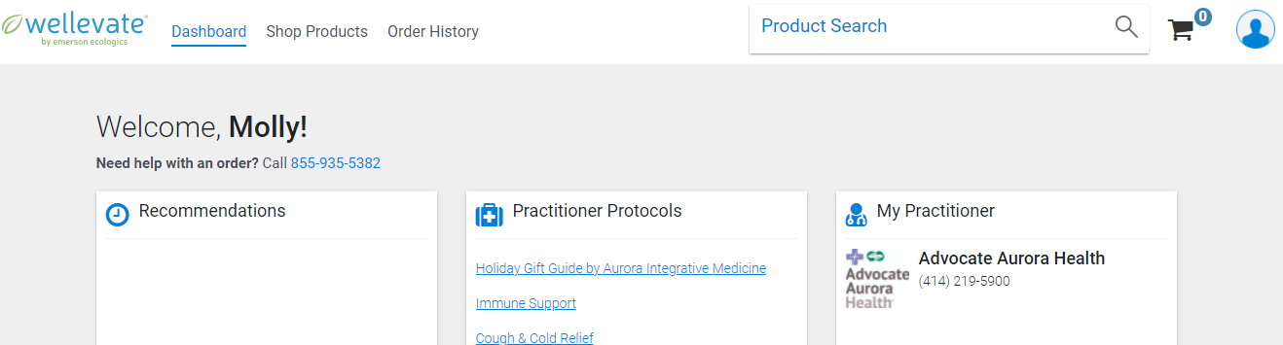

The search for ‘earseeds’ will return 12 results. The Vaccaria EarSeeds do not include the tweezers and placement guide, the other 11 products include these items and are highly recommended for this session.
- Weight Loss Ear Seed
- Anxiety Ear Seed
- Headaches/Migraines Ear Seed
- Stress Ear Seed
- Swarovski Crystal Ear Seed
- Stop Smoking Ear Seed
- Insomnia Ear Seed
- Depression Ear Seed
- Memory Ear Seed
- Multi-Condition Reference
- Back Pain/Sciatica Ear Seed

Once you choose the kit right for you, please click ‘add to cart.’ A dialogue box will pop up asking if you would like to participate in auto-refill services. At the top right of the dialogue box, you will see a blue ‘Checkout’ button. Click the ‘Checkout’ button to proceed without enrolling in auto-refill.
Orders typically arrive in 4-7 business days. We recommend ordering early to avoid any shipping or supply chain delays.

